Images

Download the Blynk app from the Google Play Store and create a new account or Login into your existing account.

After login, first, click on the ‘New Project’ to start a new project.

Configuring Blynk step1

Then give a name for your project. Select ‘Arduino Uno’ in the CHOOSE DEVICE option and ‘Bluetooth’ in CONNECTION TYPE. Then click on

‘Create.’

After this, Blynk will send an Authorization to the registered Email id. Note down the Auth Token Code. It will be used in the Program

Configuring Blynk step2

Now go to the Widget box and select the ‘Bluetooth’ widget. Click on Bluetooth and then click on ‘Connect Bluetooth Device.’ Before that, turn on the Bluetooth of your phone and select ‘HC-05’, if it asks for a PIN, then enter 1234.

Then again, go to the Widget box and select the ‘Table’ widget. Click on

Configuring Blynk step3 Table widget and select virtual pin ‘V0’ as INPUT.

Configuring Blynk step4

Now click on the ‘Play’ button to run your project.

:

Configuring Blynk step5

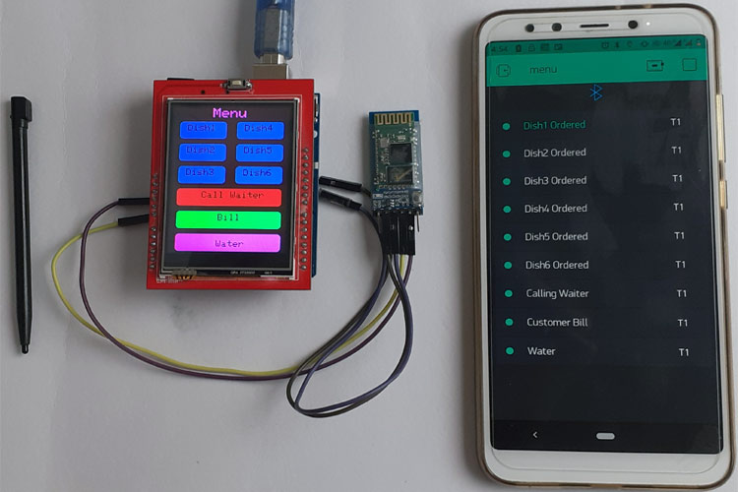

VIDEO LINK:

1. [https://drive.google.com/file/d/1waaksIm-Qim2D25jj6oyKD7yBWzxeZwo/view?usp=drivesdk](file:///C:\Users\Lenovo\Downloads\LINK)
2. <https://drive.google.com/file/d/1wfU29t2Lseu12Vvx5Kr9ojVKBk2nVUVD/view?usp=drivesdk>